1. Class: Motorcycle

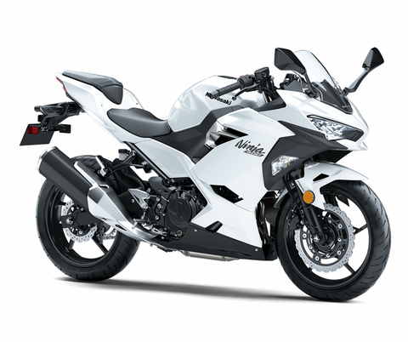

Attribute: Brand, colour, model

Behaviour: Distance travel, sport, cruising

1. Class: Computer

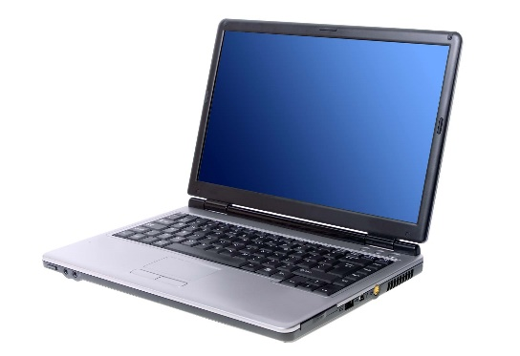

Attribute: Brand, type, colour, screen resolution

Behaviour: education, banking, work, entertain

1. Class: Phone

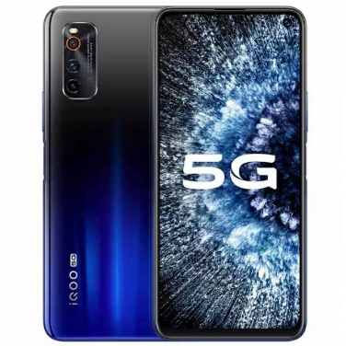

Attribute: Brand, type, colour, screen resolution, operating system

Behaviour: education, banking, work, entertain

1. Class：Pressure cooker

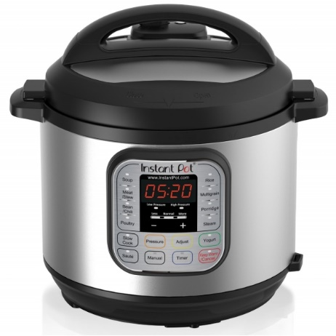

Attribute: Brand, colour, model, type

Behaviour: cook rice, heating the food, soup cooking

1. Class: Bag

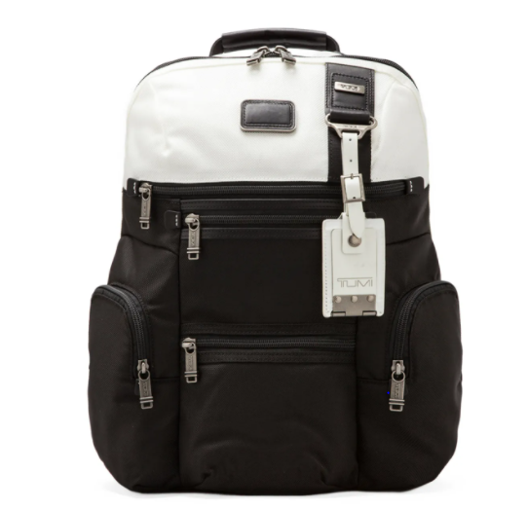

Attribute: Brand, colour, size, type

Behaviour: travel, education, working